**Setting Up Application**

**Environment**

**Install IBM Cloud**

**CLI**

|  |  |
| --- | --- |
| Date | 10 Nov 2022 |
| Team ID | PNT2022TMID11845 |
| Project Name | Smart Fashion Recommender Application |

**Step 1:**

Login to your IBM Cloud [***https://cloud.ibm.com/login***](https://cloud.ibm.com/login)[a](https://cloud.ibm.com/login)nd in-search bar you can type Container registery and click to get started.

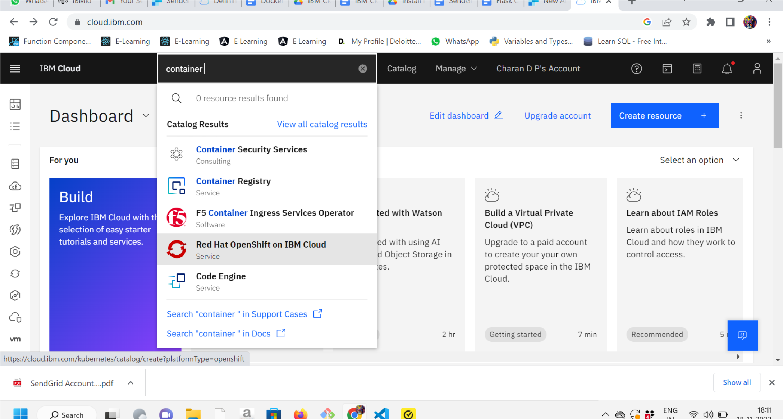

**Step2:** Click Get Started

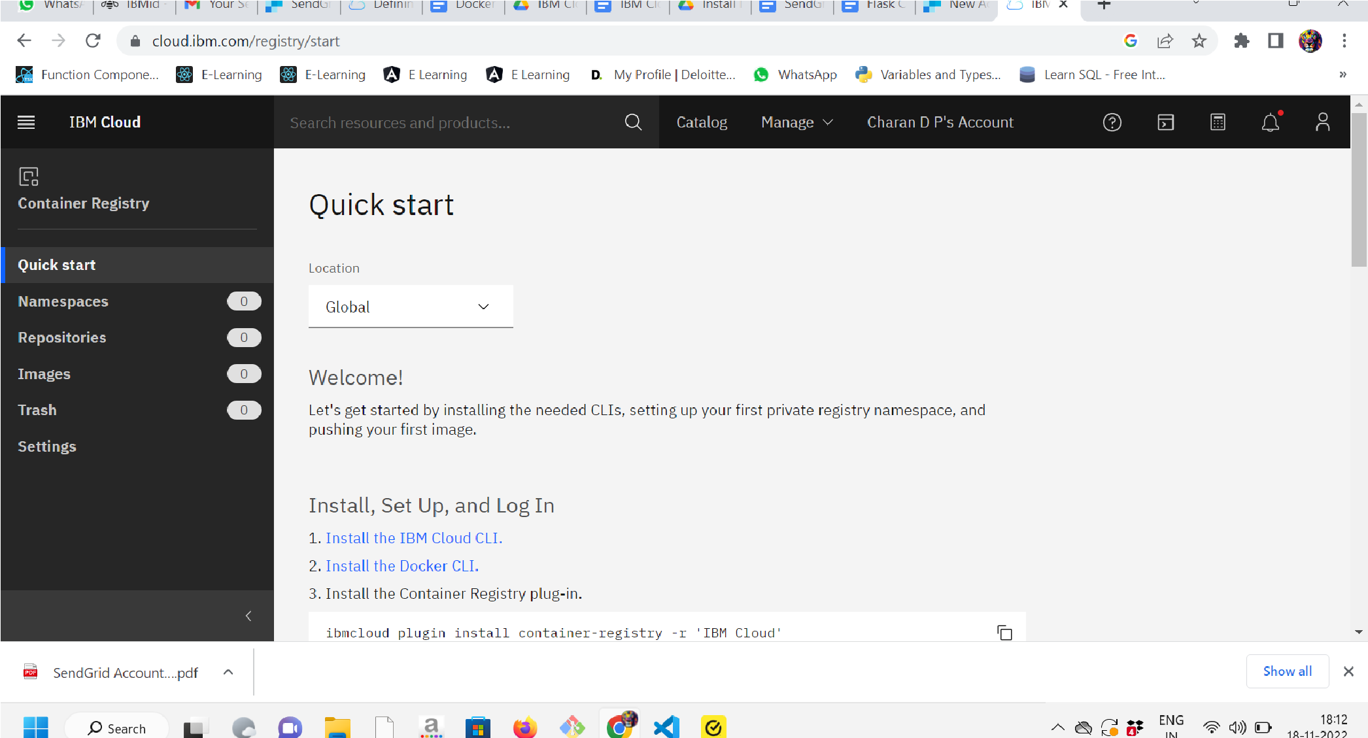

**Step 3:**

Run the command in power shell,

***(NewObjectNet.WebClient).DownloadString('https://clis.cloud.ibm.com***

***/install/powershell')***

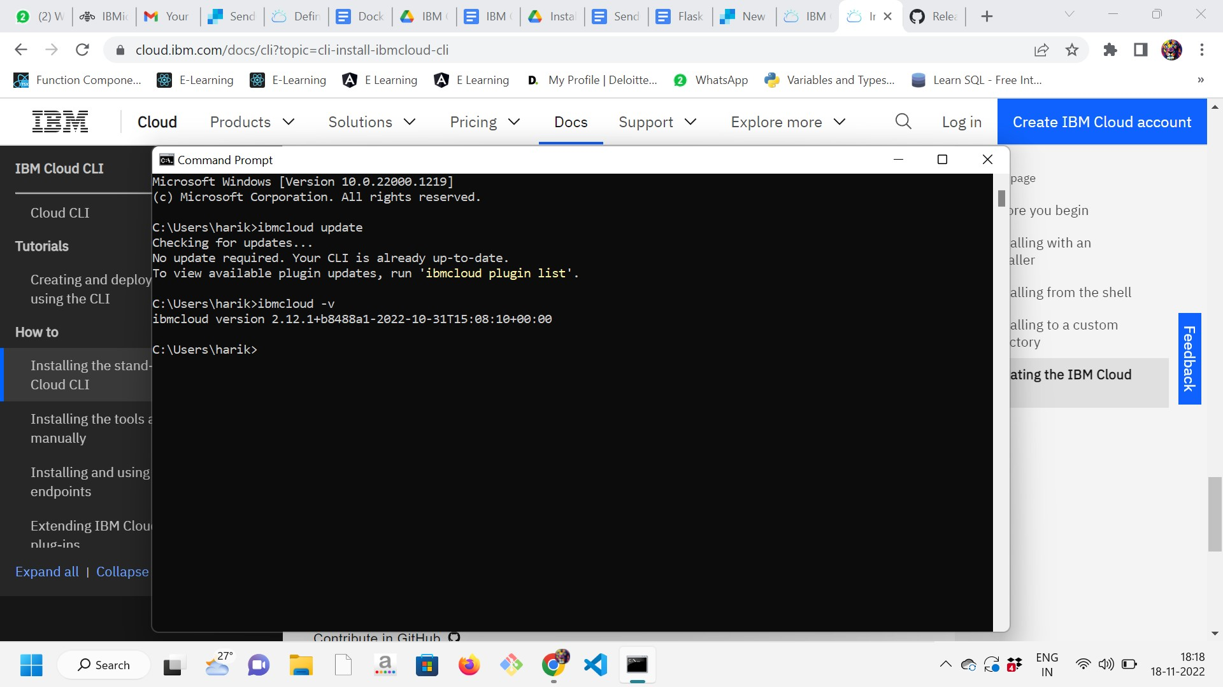

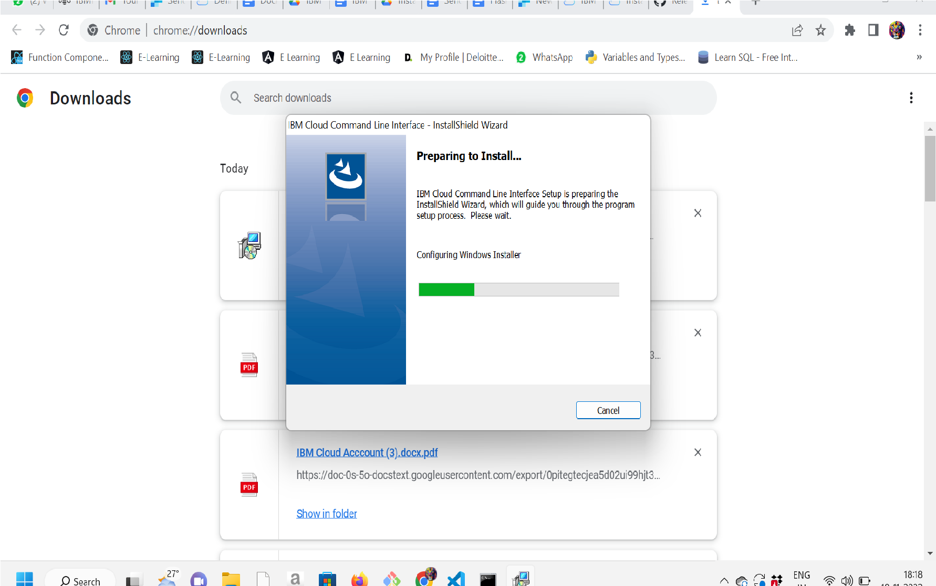

**Step 4:**

Enter the command in cmd prompt:

**Step 5:**

Run all the command one by one in cmd

[***https://cloud.ibm.com/docs/containers?topic=containers-cs_cli_install***](https://cloud.ibm.com/docs/containers?topic=containers-cs_cli_install)

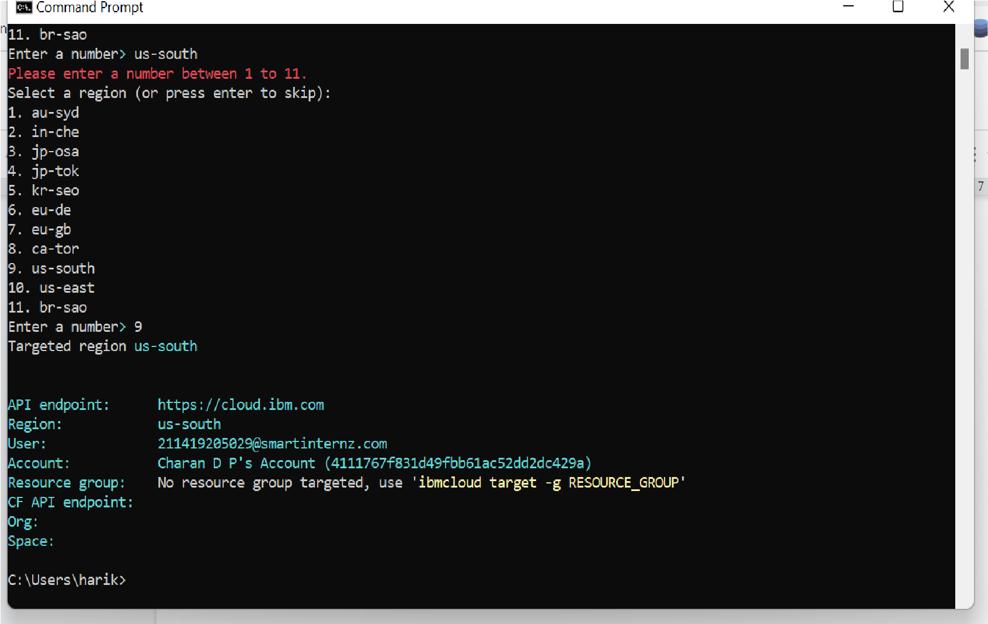

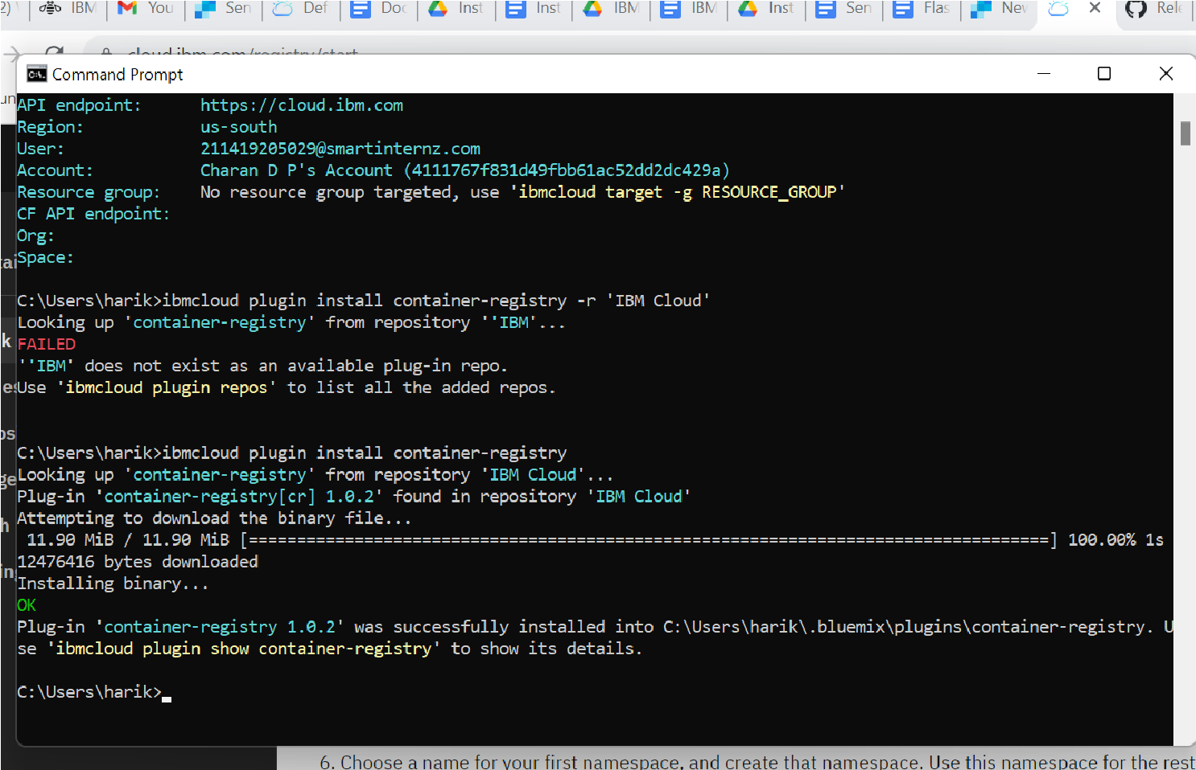

**Step 6:**

Finally, you will get the IBM CLOUD CLI in your desktop